**Life in United States**

**Northern Illinois University**

**OMIS 645**

**Dr. Kishen Iyengar**

**December 5, 2018**

**EXECUTIVE SUMMARY**

The United States is a country that has people from different backgrounds and cultures. Consideration that our class consists of mostly immigrant students we thought it would be a good idea to show some of the interesting (unexpected) factors about the United States. In order to do this, we considered some of the key factors that people look into such as crime, education and employment. In this report, we did not include statistical findings that are obvious; our report mostly highlights interesting observations (observations that oppose popular opinion) that we made while analyzing our data.

Crime rate is an important factor in determining the standard of living of a state or a country as a whole. Crime rate can actually affect the economy and reputation of a state or country. This is why a lot of people do a lot of research about a location they plan to reside in for a long time or even for a short visit. It is based on this premise that we decided to analyze crime. Our aim is to identify methods used by the government to curb crime. We will analyze these methods to see if they solve crime in our environment as we expect.

Education is regarded as the lifeblood that empowers human beings with the knowledge and skills required to survive in the world. Education is widely regarded as a solution to global problems such as equality, independence, poverty, safety, employment and many more factors. Several past reports show the impact of education on world problems listed above. Based on past reports, organizations, institutions and similar bodies have set up initiatives to educate the world. Our report on education aims to analyze the impact of these initiatives and to also study the standard of living of the people who pass education (teachers) to the children of the world.

The importance of employment in a society cannot be overstated. The stability of an economy depends a lot on unemployment rate and thus every state and country aim to keep unemployment at the minimum. In our report, we are analyzing employment in the United States and some of the more interesting factors about employment.

**VARIABLE EXPLANATION**

**Crime**

* Reported violent and property crime rate per 100,000 population: this consists of the crimes reported in each state, normalized by population of each state.
* Reported arrest rate for violent and property crimes per 100,000 population: normalized number of arrest done in each state.
* Number of police officers for 100,000 population: number of police officers working in each state, normalized by population of each state.
* Death penalty: categorical variable, with 1 for states with death penalty and 0 for states without death penalty.

**Inequality:**

* Income inequality: ranges from 0 to 1, where 0 means that the entire population receives equal income, and 1, where all the income is earned by a single person.
* Percent of non-white people: cumulative percent of Hispanic, Black and Asia population in each state.
* Unemployment rate: total unemployed, as a percent of the civilian workforce

**Education**

* HS graduates: percentage of high school graduates.
* Average teachers’ salary: this is the average salary of teachers in each state, primary and secondary school teachers in public schools have same salaries.
* Total SAT: The total average SAT score for students in each state.
* Teachers with MS and above: this contains the data for teachers with a master's degree or a higher educational degree.

**Other demographics information**

* Female population: percentage of female population.
* Percent of democrats: cumulative percent of registered democrats in each state
* Percent of republicans: cumulative percent of registered republicans in each state

**QUESTIONS**

1. **Does a stronger police force deter crime?**

To better understand how stronger police force deters crime we have performed a moderation analysis of how *number of police officers* moderates the relationship between the *number of* *reported arrests* dependent on the rate of *violent and property crimes*. Initially, we started with the multiple linear regression analysis, which output is presented below:

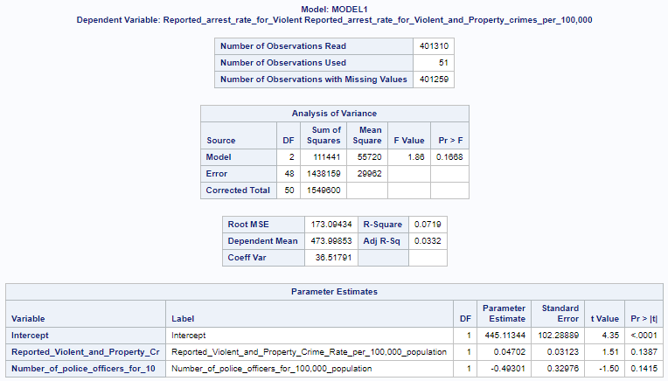

**Interpretation:**

Looking at the adjusted R square value we can say that 3.32 % of variance in *reported arrest* for *violent and property crimes* can be explained by the model.

**The linear regression equation:**

*Reported arrest for violent and property crimes = 445.1 + 0.047 Reported violent and property crime – 0.49301 Number of police officers.*

Looking at the Analysis of Variance we can say that the P-value of the model is more than alpha, thus we fail to reject the null and say that the model is bad. This could be because of the correlation between the *number of reported crimes* and the *number of police officers working*.

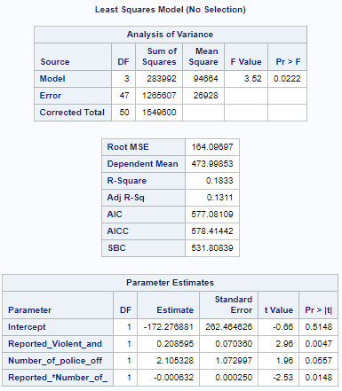To see if the *number of police officers* moderates the relationship between *reported violent and property crime rate* and *reported arrests for these crimes*, we performed a moderation analysis.



**Interpretation:**

From the Analysis of Variance table, we can say that the P-value is less than alpha, so the model is good.

**The linear regression equation:**

*Reported arrest for violent and property crimes = -172.28 + 0.21 Reported violent and property crime +2.11 Number of police officers – 0.000632 Reported violent and property crime * Number of police officers*

13.11% of variance in *reported arrest for violent and property crimes* can be explained by the model with the moderation effect, which is by 10% more than a multiple regression model.

As p<alpha we reject the null hypothesis and say that there is and interaction effect, thus, the *number of police officers* moderates the relationship between *reported arrests for violent and property crimes* and the rate of these crimes.

In conclusion we can say that the number of police officers decreases the impact of crime rate on the number of arrests. As the number of new appointed police officers does not increasing as rapidly as the crime, we observe the negative coefficient of the moderator.

1. **Do crimes happen more often in the inequal societies?**

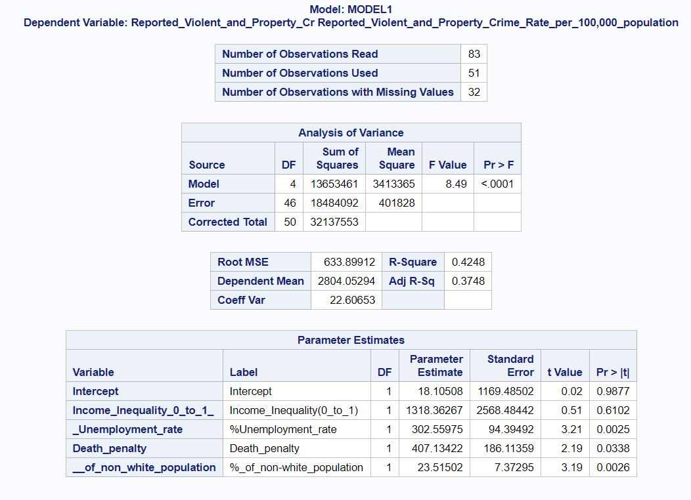To answer this question, we ran a multiple linear regression model with the *reported violent and property crime rate* as a dependent variable on *income inequality*, *unemployment rate, minorities percent of the population,* andthe *death penalty*. Each of the above-mentioned independent variables represents inequality to a certain extend.

Both F-value and P-value in the “Analysis of Variance” table illustrate that the model is a good fit. The selected model explains 37.48% of variance in the *reported violent and property crime* rate of the state.

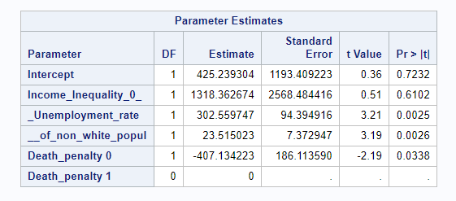

The “Parameter Estimates” table illustrates that all the independent variables, except for *income inequality* and an intercept, have a P-value less than alpha. That means, that *unemployment rate, death penalty* and the *percent of non-white population* (%_of_non-white population) impact the *reported violent and property crime rate.*

**The linear regression equation: $Report.Violent\&Propert.Crime rate= 425.24+1318.36*Income Inequality+302.56*Unemployment rate+23.52*Percent of non-white pop-407.13*No Death penalty$**

**Interpretation:**

* Per unit increase in *unemployment rate*, the *reported violent and property crime rate* increases by 302.56 units.
* Per unit increase in the *percent of non-white population* in the population the *reported violent and property crime rate* increases by 23.52 units.
* Per unit increase in the number of states with “no *death penalty*” the *reported violent and property crime rate* decreases by 407.13 units compared to the states with *death penalty*.

In conclusion we can state that with the increase in the *percent of non-white population* and *unemployment rate,* the *reported violent and property crime rate* also increases. The *reported violent and property crime rate* in states without *death penalty* is less than in states with *death penalty*, while the *income inequality* doesn’t impact the *reported violent and property crime* rate.

1. **Does income inequality depend on the party affiliation?**

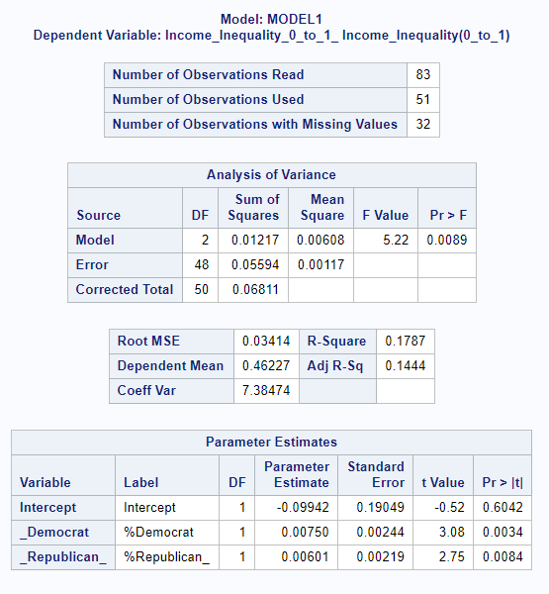In order to understand whether the *income inequality* depends on the *party affiliation* we ran a multiple linear regression model of *income inequality* being depend on the percent of democrats and the percent of republicans in each state.

Both F-value and P-value in the “Analysis of Variance” table illustrate that the model is a good fit. The selected model explains 14.44% of variance in the income inequality.



The “Parameter Estimates” table illustrates that all the independent variables, except an Intercept, have a P-value less than alpha. That means, that both *percent of the republicans* and the *percent of democrats* in the state impacts its inequality.

**The linear regression equation: $Income Inequality=-0.099+0.0075*Percent of Democrats+0.00601*Percent of Republicans$**

**Interpretation:**

* Per unit increase in *percent of democrats* the *income inequality* increases by 0.0075 units.
* Per unit increase in *percent of republicans* the *income inequality* increases by 0.00601 units.

In conclusion we can state that *income inequality* doesn’t significantly differ between democratic and republican states, however, with the increase in the *percent of republicans* the *income inequality* increases less than with the increase in *percent of the democrats*. This can be supported by the fact that in states with more Democrats there will be more heterogeneous population which will explain this discrepancy.

1. **How does students’ success and teachers’ level of education predict a teacher’s salary?**

In order to understand the educational sector more, we decided to analyze what significant factors have effect on teachers’ average salary. We conducted a multiple linear regression to see if the *total SAT score*, as a criterion of student’s success, and the *percent of teachers with master’s degree or higher* impact the average state salary of teachers.

H0: the model is not a good fit

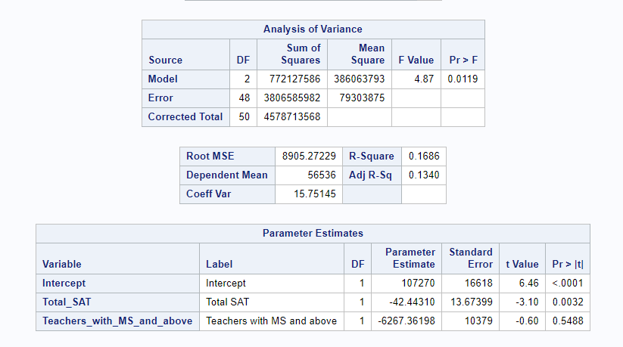H1: the model is a good fit



**Interpretation**

From the above results of our analysis, we can see that the model is significant, because the F- statistics P-value is less that Alpha (0.05). Also, we observe the adjusted R-Square; 13.4% of the variance in SAT scores is explained by *teachers with masters and above* and *total SAT* scores.

**Linear regression equation: $Average Teachers’ salary = 107,270 – 6,267.36 * Teachers with MS or higher – 42.44 * Total SAT$**

Contradictory to our assumption before running this model, we can see that a master's degree or higher does not have any role in determining the salary of teachers. We also noticed that for a unit increase in *total SAT*, the *average teacher’s salary* decreases by 42.44 which is opposite to what we expected. It can be explained by the fact, that schools in states with lower SAT scores receive more government funds to improve students’ performance. These funds have a direct impact on the teacher’s average salary in the state.

1. **Would a fee waiver impact the result of the SAT score?**

Different organizations and institutions award *fee waivers* to low income students who are unable to afford the fees for the exam. We decided to analyze the data we have to find out if there is a difference in the *total SAT* results of students with and without a waiver. We conducted a two tailed test to conduct our analysis.

H0: Fee waivers do not cause a difference in students SAT scores

H1: Fee waivers cause a difference in students SAT scores

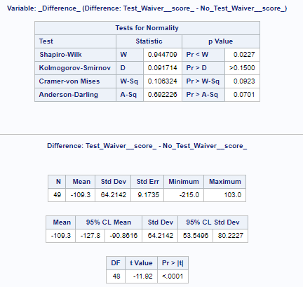

**Interpretation**

From the above results of our analysis, we observe that the P-Value is less than alpha (0.05), hence there is a difference in students’ *total SAT* scores for *students without a fee waiver* and *students with a fee waiver*. On further analyses we observe that the T value is -11.92 meaning that students who get fee waivers have lower achievement scores on the exam.

1. **Does High school graduation rate impact the relation between females and the birth rate?**

To better understand how high school education changes the relationship between *female population* and the *birthrate*, we ran a moderation analysis with *birth rate* as a dependent variable. Below are the results of the multiple linear regression which we performed prior to moderation analysis:

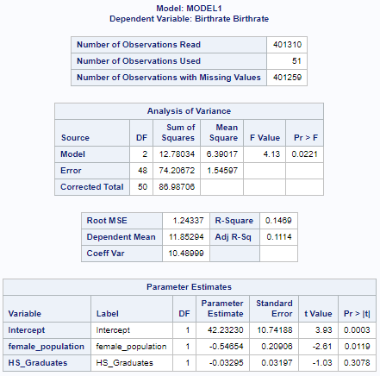



**Interpretation:**

Looking at the Analysis of Variance we can say that the P-value is less than alpha, so we reject the null and say that the model is good. Looking at the adjusted R square value we can say that 11.14 % of variance in *birthrate* can be explained by the model.

**Linear regression equation: $Birth Rate=40.97 – 0.54654 Female population – 0.033 HS Graduates$**

* With a unit increase in the *female population* the *birthrate* decreases by 0.54.
* With a unit increase in *HS graduates* the *birthrate* decreases by 0.033.

Now we have done a moderation analysis to see if *HS graduates* moderates the relationship between *female population* and *birthrate*.

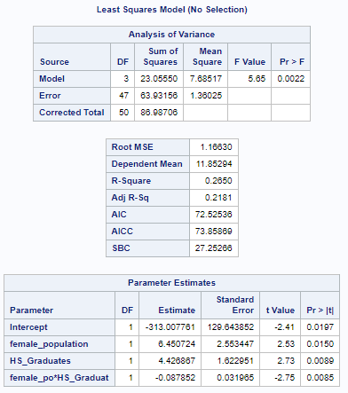



From the Analysis of Variance table, we can say that the P-value is less than alpha, so the model is good. 31.81% of variance in *birthrate* can be explained by the model.

**Linear regression equation: $Birthrate = -313 + 6.45 Female population +4.43 HS Graduates – 0.088 female population * HS Graduates$**

As p<alpha we reject the null hypothesis and say that there is and interaction effect, so *HS* *graduates* moderates the relationship between *female population* and *birthrate*.

In conclusion we can say that after receiving high school graduation the birthrate in female population is still decreasing but the magnitude of how much it is decreasing has reduced

**CONCLUSION**

In our report we have touched upon education, crime, and social inequality in the different states of the USA. We have uncovered some interesting finding and analyzed some of the social issues that impact our life here. In our analysis we learned about people biased believes on certain problems and proved that are not always right. Sometimes we need to conduct further analyses to dig deep into the root and find the cause of the question. One of the findings is that the stronger police force reduces the impact of the relationship between the crime rate and number of arrests. Another interesting finding presented in this report is about the impact of Master’s or higher degree and students SAT score on teacher’s average salary. Considering an emphasis and importance that the world pays to education, one might expect that a Master’s degree will have an impact on a teacher’s salary. Our finding prove otherwise, as well as show that with the increase in SAT score teacher’s salary is decreasing. The analysis of SAT tests fee waiver reveals that people with SAT fee waivers score worse than people without it. We also found out that per one percent increase in the percent of democrats, the income inequality in democratic states increases faster than in the republican states.

All of these findings support the need in further analyses to understand the hidden patterns in the data and the interaction between its variables. This report can be a good foundation for the further analyses to all institutions, organizations, and government bodies interested in solving societal issues. It can help them to analyze the impact of their initiatives to ensure their effectiveness in solving the societal problems.

**REFERENCES**

* <https://ucr.fbi.gov>
* <https://www.americashealthrankings.org/explore/annual/measure/gini/state/AK?edition-year=2017>
* <https://www.americashealthrankings.org/explore/annual/measure/Unemployed/state/AK>
* <https://www.americashealthrankings.org/explore/annual/measure/Graduation/state/AK?edition-year=2017>
* <https://www.cdc.gov/nchs/data/nvsr/nvsr67/nvsr67_08-508.pdf>
* <https://deathpenaltyinfo.org/states-and-without-death-penalty>
* <https://news.gallup.com/poll/226643/2017-party-affiliation-state.aspx>
* <https://www.census.gov/quickfacts/fact/table/il/BZA210216>